SQL EXERCISE

Practice and practice we can improve our skills.

Retrieve the required information using SQL language.
Activity II. Give a database schema for a library management system as the following picture.
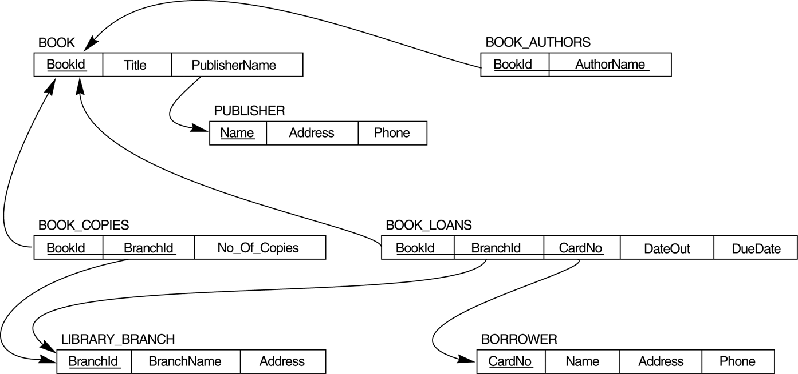

- How many copies of the book titled The Lost Tribe are owned by the library branch whose name is "Sharpstown"?
- How many copies of the book titled The Lost Tribe are owned by each library branch?
- Retrieve the names of all borrowers who do not have any books checked out .
- For each book that is loaned out from the "Sharpstown" branch and whose DueDate is today, retrieve the book title, the borrower's name, and the borrower's address.
- For each library branch, retrieve the branch name and the total number of books loaned out from that branch.
- Retrieve the names, addresses, and number of books checked out for all borrowers who have more than five books checked out.
- For each book authored (or co-authored) by "Stephen King", retrieve the title and the number of copies owned by the library branch whose name is "Central"

Activity III Give a database schema of a company as the following picture.
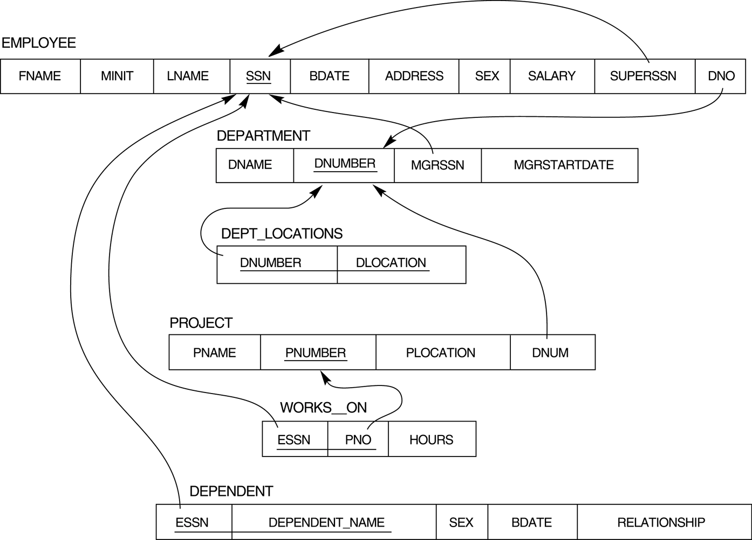

- Retrieve the names of employees in department 5 who work more than 10 hours per week on the 'ProductX' project.
- For each project, list the project name and the total hours per week (by all employees) spent on that project.
- Retrieve the names of employees who work on every project.
- Retrieve the names of employees who do not work on any project.
- Find the names and addresses of employees who work on at least one project located in Houston but whose department has no location in Houston.
- List the last names of department managers who have no dependents.
- Find details of those employees whose salary is > the average salary for all employees. Output salary in descending order.
- Find details of those employees whose salary is > the average salary for all employees in his/her department. Output salary in ascending order.

